Z:\Documents\Ramp_Rebrand\NewRampID_left.wmf

DocuSign Signature Solution Setup Guide

Prerequisites to run the DocuSign project:

1. A server (32 or 64 bit) running Windows Server 2003 or Windows Server 2008 with Service Packs installed.
2. Install Visual Studio 2008.
   1. .Net Framework 3.0 is required to install WSS 3.0 which will be installed by VS 2008. Else you will have to download and install the framework separately.
3. Download WSS 3.0 with sp2 in <http://sharepoint.microsoft.com/product/related-technologies/Pages/windows-sharepoint-services.aspx> based on the system configuration (32-64 bit).
4. Now Setup the DocuSign Signature Solution (uploaded on the demo server (***DocuSign\_Feature\_Solution.zip***) by double clicking the Solution file.

DocuSignSignature Solution

1. Setup the DocuSignSignature Solution.
2. The solution has two projects **DocusignSignature** and **DocuSignSignature.WebConfigModification** as shown in figure 1.

**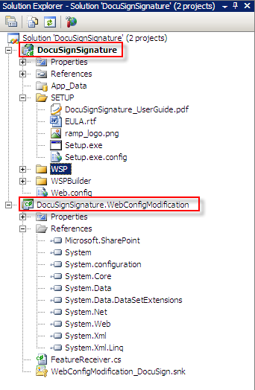**

**Figure 1**

1. **DocuSignSignature** Project has the layouts, page templates and other resource files needed to create the Setup file for the SharePoint feature.
2. **DocuSignSignature.WebConfigModification** Project has the logic to make the web configuration changes needed for the feature setup on a SharePoint site, on which this feature is installed.
3. More details are provided in the sections below.

**DocuSignSignature.WebConfigModification Project**

1. This project is used to add the references and settings required for the DocuSign feature in the Web.Config file of a SharePoint site where the site is installed.
2. DocuSign feature needs following user inputs in the web.config file.
   1. Smtp server name,
   2. DocuSign Service username to access the DocuSign web services and
   3. Service account password
3. The default dummy values set for these fields in the FeatureReceiver.cs are shown in **Figure 2** below

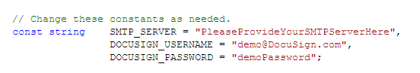

**Figure 2**

1. One can set these fields with their SMTP/DocuSign details and rebuild this project, followed by a rebuild of the DocuSignSignature Project and use the updated Setup files in the SETUP folder of the DocuSignSignature project to install the feature.
2. Else, a user will have to manually browse to the SharePoint site web.config file and change the values for every site where the feature is installed.
3. When the project **DocuSignSignature.WebConfigModification** rebuild is successful, one can notice the **DLL (DocuSignSIgnature.WebConfigModification)** in the GAC folder of the DocuSignSignature Project shown in **Figure 3** gets updated.

**Figure 3**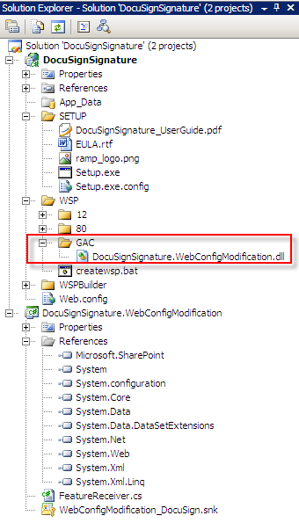

1. Now build the DocuSignSignature Project and use the updated Setup files available in the SETUP folder that project.

**DocuSignSignature Project**

1. This is the project which creates the SETUP executable and puts together all other supporting files needed for the feature setup.
2. It consists ofSETUP, LAYOUTS, BIN and GAC folders as shown in Figure 4. They folders structure defines the corresponding locations in the SharePoint site where the content of these folders will be deployed during the installation process.

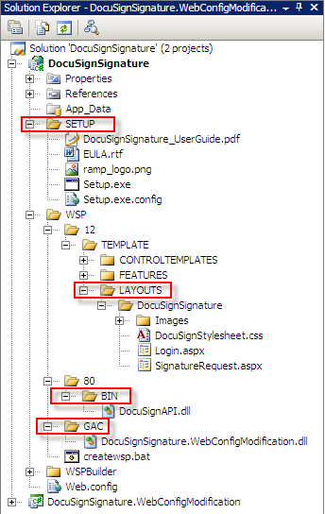

**Figure 4**

SETUP:

* The content of this folder is sufficient to install the DocuSign feature on a server.
* If any changes are made in the solution, rebuild the DocuSignSignature project and use the files in the SETUP folder for installation.
* It consists of user guide (**DocuSignSignature\_UserGuide.pdf**) which describes how to install, activate, deactivate and uninstall the feature.
* EULA.rtf has the DocuSign API SDK License agreement.

LAYOUTS:

* All the pages (Login.aspx, SignatureRequest.aspx), images, and style sheet for the pages used by the DocuSignSignature feature are available in this folder.
* If any of these resource files are modified, rebuild the project and install the feature (again after uninstalling, if already installed) using the new SETUP files.

BIN:

* It consists of **DocuSignAPI.dll** that will be copied into the bin folder of SharePoint site (where DocuSignSignature feature installed).

GAC:

* The content of this folder will be copied to the System GAC when the Feature is installed.
* This folder has the **DocuSignSignature.WebConfigModifcation.dll** which will be updated every time the **DocuSignSignature.WebConfigModifcation** project is built.

Please note that this Solution is only to build and create the Setup package and cannot be executed for a preview of any feature functionality.

One has to install the feature using the Setup files on a SharePoint site and then view the feature.